AIT 524: Weekly Assignment 11
Tanmoy Chowdhury
George Mason University

Author Note
This task is being submitted as an assignment task 11 for the course ‘Database Management Essential’ offered in Sprig 2018. For any kind of inquiry, feel free to contact at tchowdh6@masonlive.gmu.edu.

Online Drill
The ERD from assignment 04 & 06 has been used here.
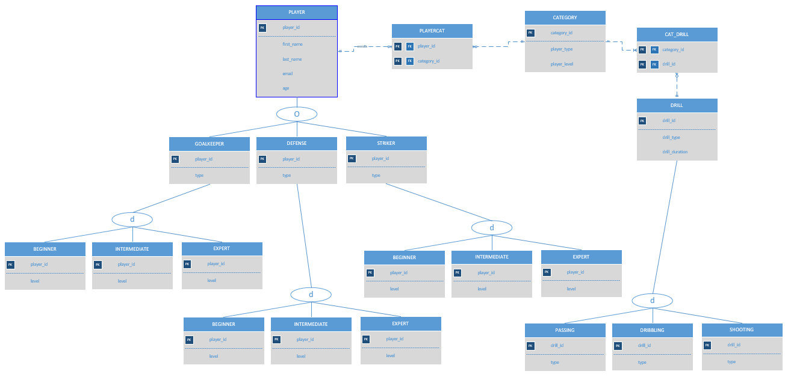
Figure 01: ERD from Assignment 04

Modification:
- I edited the entity name ‘BEGINNER’, ‘INTERMEDIATE’, ‘EXPERT’ as it seems like confusing for me when I am creating this subclass under their parent classes.
- I did not create ‘PASSING’, ‘DRIBBLING’ AND ‘SHOOTING’ entities as they inherit the same attribute from their parent class ‘DRILL’.
- I preferred to use all upper case in command and table name.

Presentation:
A SQL file has also been attached in submission attempt.
Procedure & Output:
- Write SQL queries to join two or more tables where each query contains multiple nested single-row functions. Make sure to use different functions in each query. Explain what each query is intended to do.

Explanation: This query will show players’ first and last name initial in upper case. It will also represent their id and category id. PLAYER and CATEGORY table will be combined here.

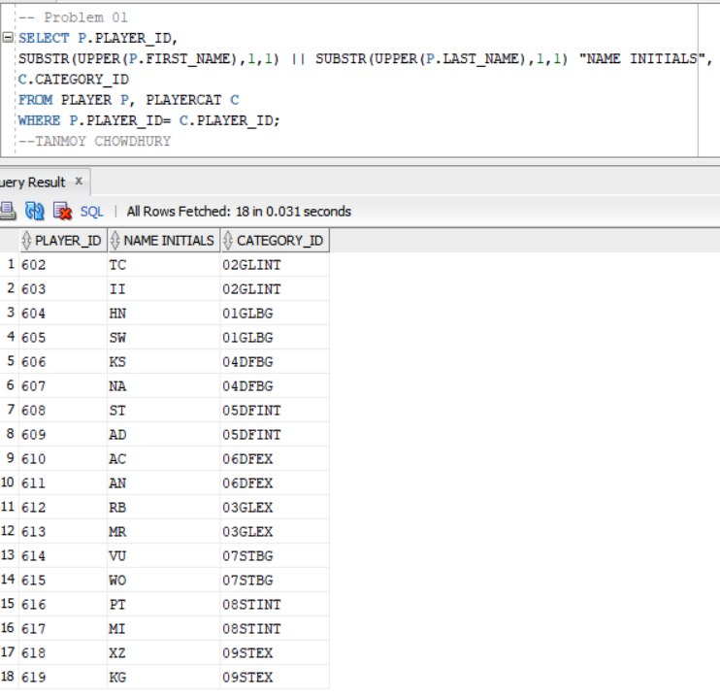

- Write SQL queries to join two or more tables where each query contains multiple nested single-row functions. Make sure to use different functions in each query. Explain what each query is intended to do.

Explanation: Players’ first and last name will concated and initial capped. It will combine PLAYER, PLAYERCAT, CAT_DRILL tables to find out the drill performed by the players.

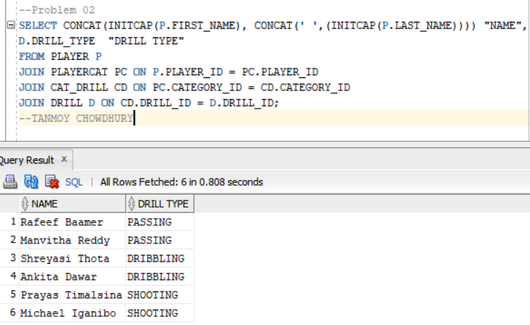

- Write SQL queries to join two or more tables where each query contains multiple nested single-row functions. Make sure to use different functions in each query. Explain what each query is intended to do.

Explanation: Players’ email domain will be find out. Their type will be retrieved by joining GOALKEEPER table with PLAYER table.

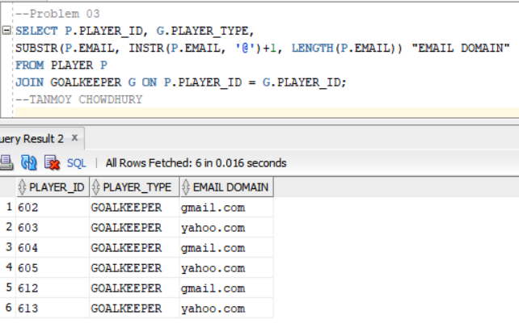

- Write SQL queries to join two or more tables where each query contains multiple nested single-row functions. Make sure to use different functions in each query. Explain what each query is intended to do.

Explanation: Players’ first name will be shown in lower case. Their type will be replaced by ‘GOALMACHINA’. Two table PLAYER and STRICKER will be joined together.

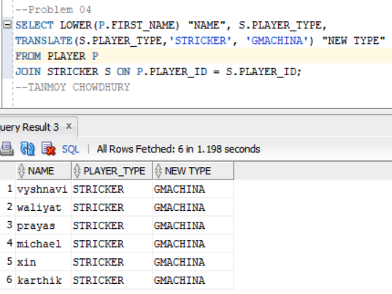

- Write a query which is based on a single table and includes the GROUP BY statement. Explain what the query is supposed to do.

Explanation: This query is showing number of players in each age group.

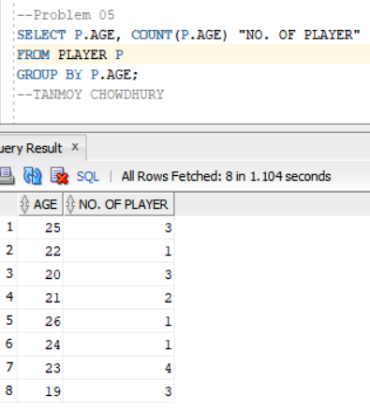

- Repeat problem 5 but add the WHERE statement. Explain what the query is supposed to do.

Explanation: This query is showing number of players in each age group where the age group belongs to only 3 groups of 19, 23 and 25 years old.

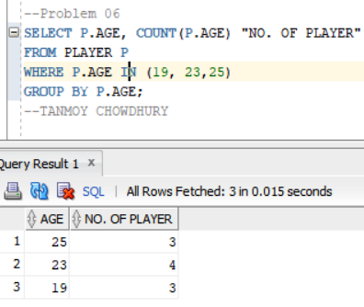

- Repeat problem 6 but add the HAVING statement. Explain what the query is supposed to do.

This query is showing number of players in each age group where the age group belongs to only 3 groups of 19, 23 and 25 years old. Among these three groups only those group which are older than 23 years old.

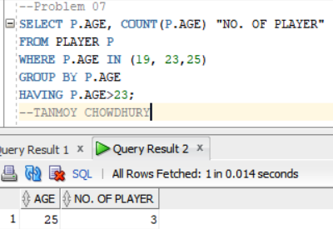

- Repeat problems 5 but use two tables.

Explanation: This query is showing number of players in each category group based on PLAYER and PLAYERCAT table.

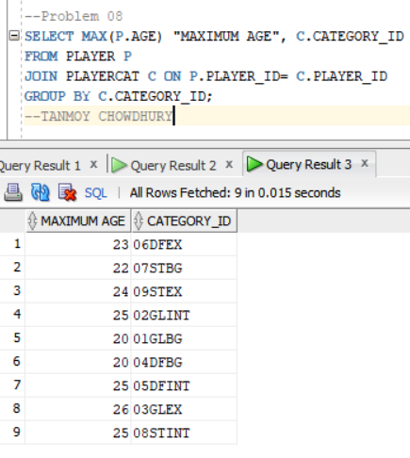

- Repeat problems 6 but use two tables.

Explanation: This query is showing number of players in each category group based on PLAYER and PLAYERCAT table; where the age group belongs to 19, 23 and 25 years old.

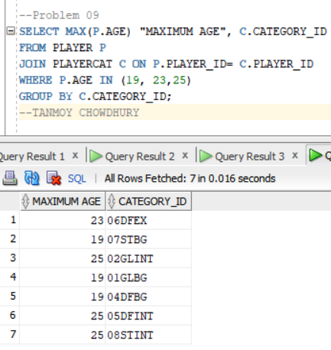

- Repeat problems 7 but use two tables.

This query is showing number of players in each category group based on PLAYER and PLAYERCAT table; where the age group belongs to 19, 23 and 25 years old. Among these groups only those group which are older than 23 years old.

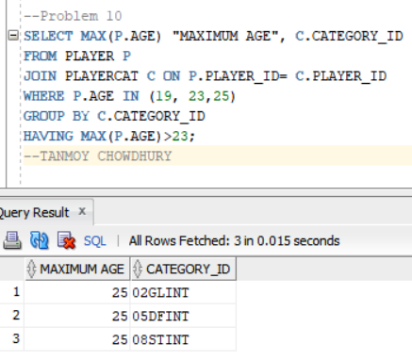
References
Casteel, J. (2016). Database system concepts and architecture in M. J. Horton, Oracle® 12c: SQL : Cengage Learning.

